1. Introduction

This section of the report will explain how the shape and size of the vehicle have been decided as well as any developments that have led to making a decision on the final design for the outer frame. *Aerodynamic*s and *efficiency* are the engineering principles used in the development of the shape/size of the *recumbent* vehicle. The research question I focused on was, “What is the ideal shape and size for an electric assist bicycle?”

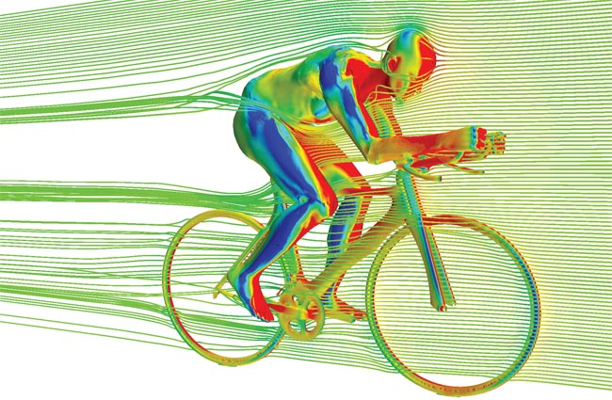

Effects of aerodynamic drag on a cyclist

1. Shape and Size

Shape and size entail the appearance, the outer frame and the dimensions of the vehicle. These aspects are significant when designing the vehicle as the vehicle will need to be small enough for a single user to pedal/move while also allowing room for housing accessories, appliances and said user.

* 1. Appearance

Appearance describes the exterior form of the Vehicle, such as the decals and paint job. The appearance of the Vehicle will be modern and *streamlined* while maintaining an edge. Simple colors and lines will draw the user’s eye to the curves of the vehicle. Different coloured models are pictured below.

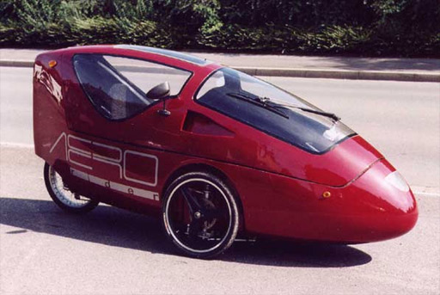 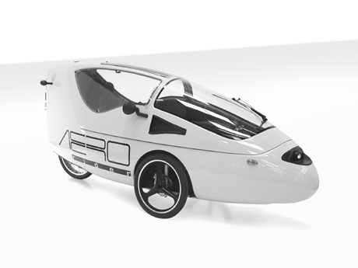

Aerorider ™ - White paint modification (Orthogonal view)

Aerorider ™ - Red paint modification

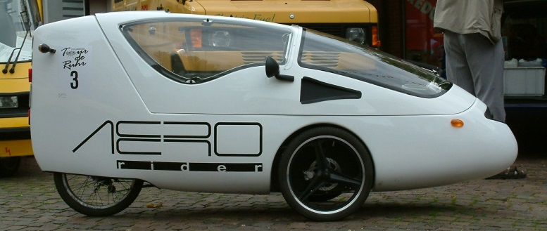

Aerorider™ - White paint modification (Side view)

All of the above models have the same basic shape and size; aerodynamic shape and small size allowing for easier manoeuvrability.

* 1. Shape

The shape will consider the winter season - and will minimize the snow collection on the roof. Aerodynamics will be carefully considered; making sure the bicycle weight will be *efficient* for all seasons and tasks provided. The model will be shaped similar to that of a raindrop, as the natural shape of a raindrop, travelling at terminal velocity has negligible air resistance, reducing *drag force*, thereby reducing the total effort required to move the vehicle. To reduce the amount of snowfall collecting on the roof of the vehicle a sloped roof will be considered, by doing so, the user does not transport as much excess weight (snow) while pedaling.

* 1. Dimensions

The dimensions of the tricycle have been specifically tailored to the size of Canadian bike lanes, enough space has been provided to comfortably fit the user as well as incorporate additional safety features. Dimensions are 2.4m long by 0.85m wide by 1.20m high (based on existing models of recumbent tricycles [3]). Each portion of the shell will be carefully considered as no space can be squandered.

Front :( Pi * radius *slant height) +   
Back :( 1.2m*0.85m) + Sides: (2*(0.6m*1.2m)) = 4.2 metres squared

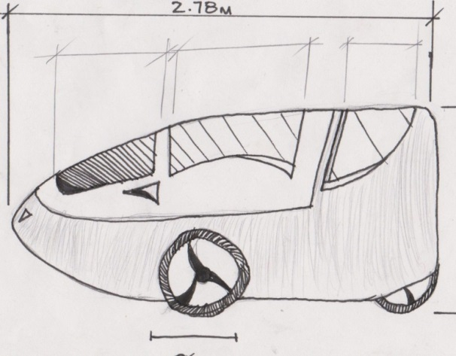To calculate the cost of materials, surface area will need to be calculated. When calculating surface area a scale drawing was done and the outer frame was broken down into smaller shapes and the sum of the area of the shapes was then calculated.

Fig. 5 Sketch of “The Vehicle”

The surface area calculated using Figure 6 was 4.2 metre squared.

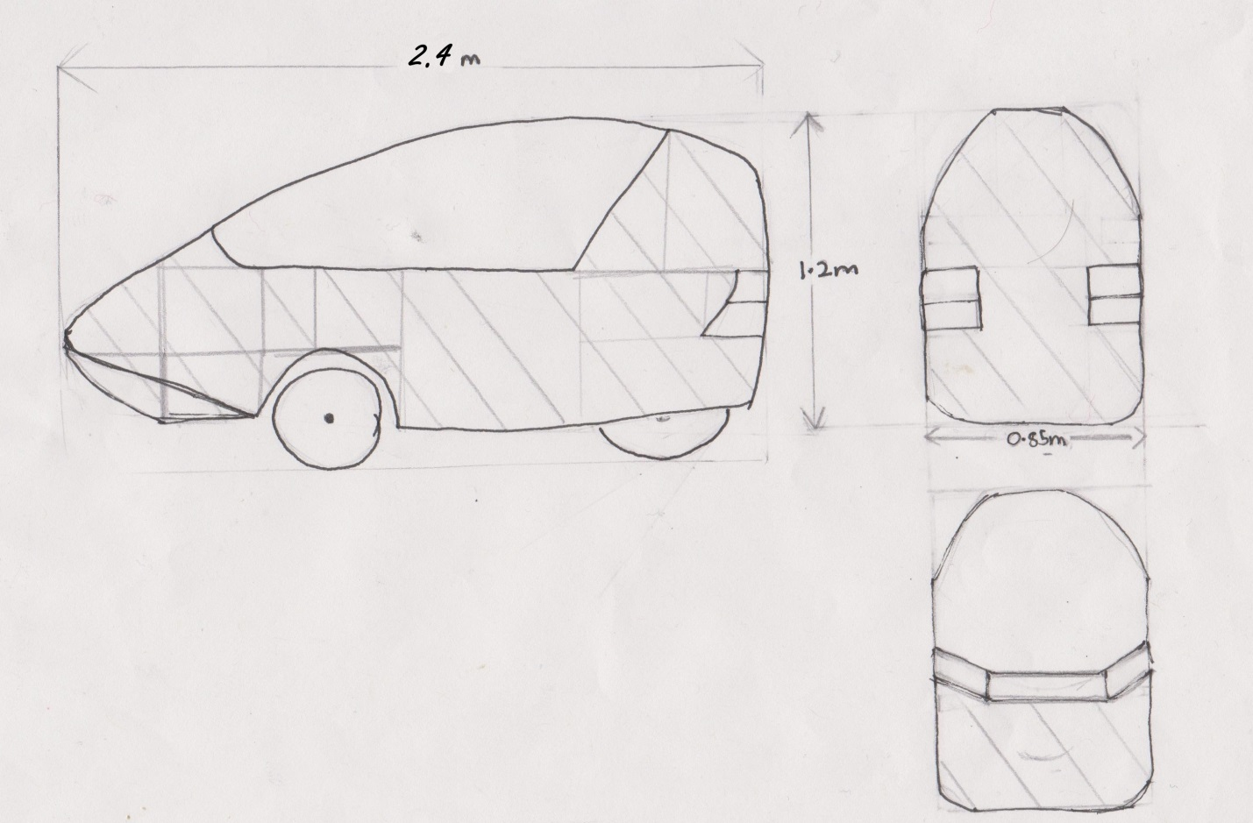

Figure Sketch of the Vehicle used in calculating surface area

3. Glossary

Recumbent: Lying down, especially in a position of comfort or rest; reclining.

Streamlined: Design or provide with a form that presents very little resistance to a flow of air or water, increasing speed and ease of movement.

Aerodynamics: The properties of moving air, and esp. of the interaction between the air and solid bodies moving through it.

Drag force: refers to forces which act on a solid object in the direction opposite to the relative motion of the body.

Efficiency: Achieving maximum productivity with minimum wasted effort or expense.

References

1. James Thomas. (July 29, 2013). *Cycling 360 media* by *Victor Jimenez* [Online]. Available: <http://www.cycling360media.com/wp-content/uploads/2012/10/Adams_STAR-CCM1_650.jpg>
2. *Matt Kelly*. (July 16, 2009*) Aerorider: The ultimate single-seat hybrid* by *Matt Kelly*[Online] Available.   
   <http://www.examiner.com/article/aerorider-the-ultimate-single-seat-hybrid>

# 3. Jeroen Haringman (August 2,2007) Test drive Aerorider[Online]

<http://www.solarwebsite.nl/en/2007/08/proefrit-aerorider/>

# 4. Unknown.(December 22, 2010) [Handbuch für Elektrofahrräder & Pedelecs](http://www.nielsfries.de/literatur/pedelec/handbuch-fur-elektrofahrrader-pedelecs/)[Online]

<http://www.nielsfries.de/literatur/pedelec/handbuch-fur-elektrofahrrader-pedelecs/>

# 5. Unknown.(December 22, 2010) [Handbuch für Elektrofahrräder & Pedelecs](http://www.nielsfries.de/literatur/pedelec/handbuch-fur-elektrofahrrader-pedelecs/)[Online]

<http://www.nielsfries.de/literatur/pedelec/handbuch-fur-elektrofahrrader-pedelecs/>